**ABSTRACT**

Our project Hospital Management system includes registration of patients,

storing their details into the system, and also computerized billing in the pharmacy,

and labs. Our software has the facility to give a unique id for every patient and

stores the details of every patient and the staff automatically. It includes a search

facility to know the current status of each room. User can search availability of a

doctor and the details of a patient using the id.

The Hospital Management System can be entered using a username and

password. It is accessible either by an administrator or receptionist. Only they can

add data into the database. The data can be retrieved easily. The interface is very

user-friendly. The data are well protected for personal use and makes the data

processing very fast.

**REQUIREMENT OF PROPOSED SYSTEM**

The first step in system development life cycle is the identification of need

of change to improve or enhance an existing system. An initial investigation on

existing system was carried out. The present system of hospital is completely manual. Many problems were identified during the initial study of the existing system. To develop this software detailed study is made at local hospital. Based on the information collected it is decided to maintain the basic information about doctors and patients.

**USED INSTRUEMENT THAT WE NEED**

1.Used XAMPP Server to store it. 2. Used Macromedia Dreamweaver 8 to write down HTML & PHP code. 3. It is faster than manual system. 4. Efficiently maintains the details about the patient.

5. Simultaneously updates changes made to any data, item in the entire data base.

**PROGRAM DESIGN**

**DOCTOR MODULE**

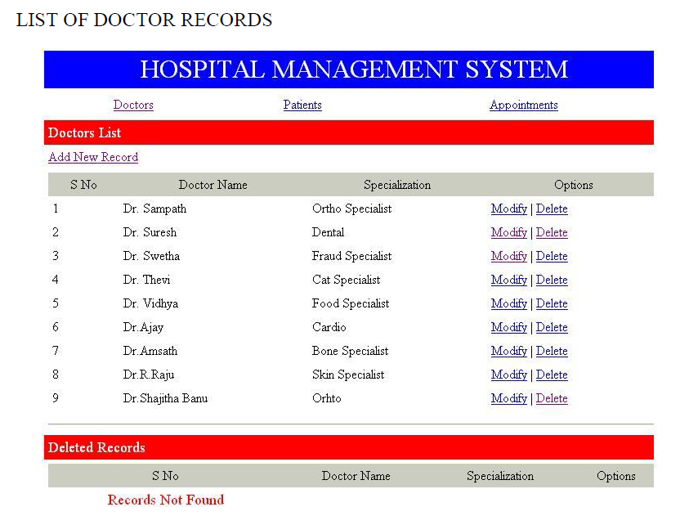

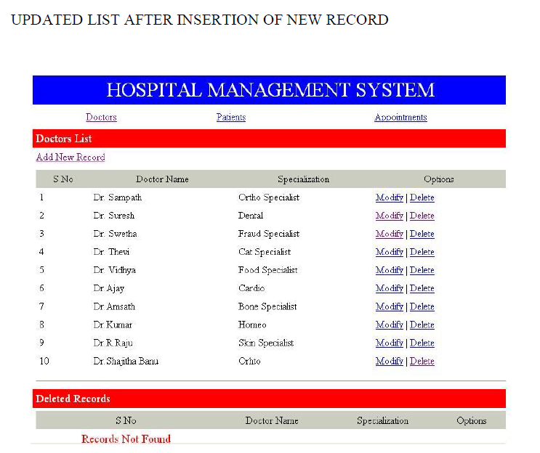

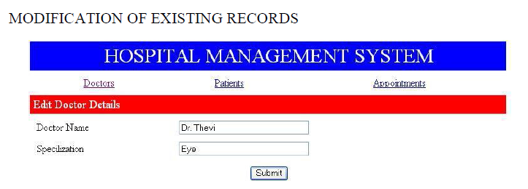

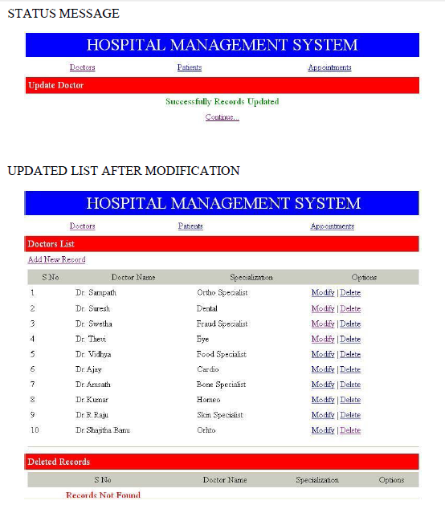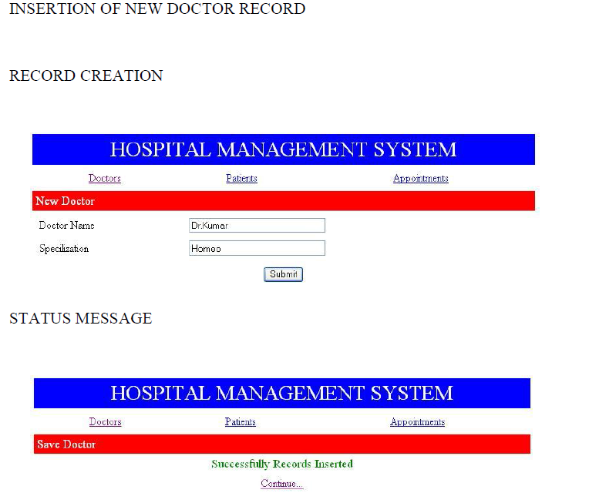

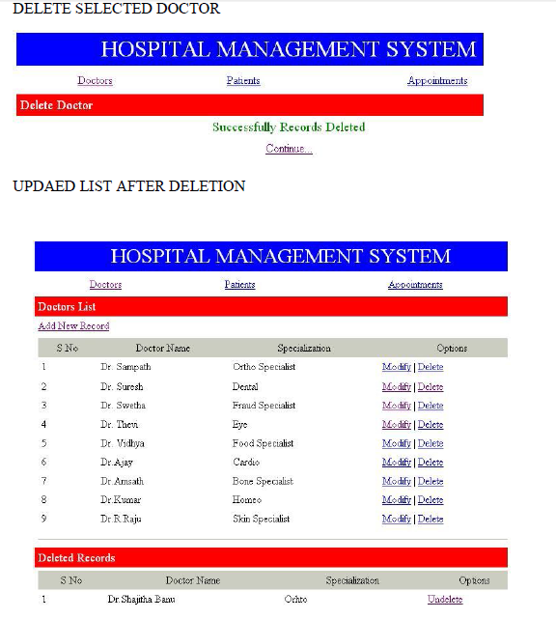

**DATABASE DESIGN**

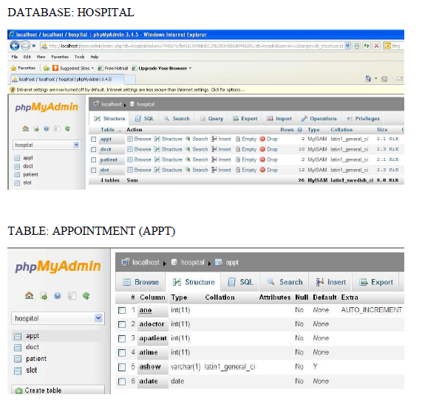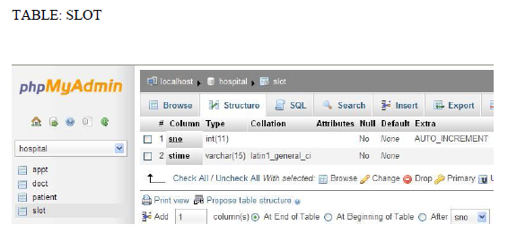

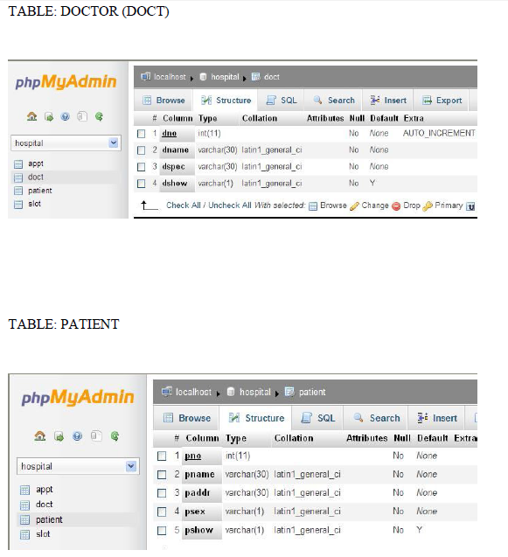

**ADVANTAGES**

• It is fast, efficient and reliable

• Avoids data redundancy and inconsistency

• Web-based

• Number of personnel required is considerably less

• Provides more security and integrity to data

**CONCLUSION**

The HOSPITAL MANAGEMENT SYSTEM is a great improvement over

the manual system using case fields and paper. The computerization of the system

has sped up the process. In the current system, the front office managing is very

slow. The hospital managing system was thoroughly checked and tested with

dummy data and thus is found to be very reliable.

**FUTURE ENHANCEMENTS**

The proposed system is Hospital Management System. We can enhance this

system by including more facilities like billing system, inpatient room allotment

for the admitted patients and the stock details of medicines in the pharmacy.

Providing such features enable the users to include more comments into the

system.